AALIM MUHAMMED SALEGH COLLEGE OF ENGINEERING

DEPARTMENT OF COMPUTER APPLICATIONS (M.C.A.)

LAB MANUAL

MC5511 - CLOUD AND BIG DATA ANALYTICS LABORATORY

(III YEAR – V SEMESTER)

PREPARED BY

K.KHAJA MOHIDEEN, M.C.A., M.Phil.,, M.E.,
ASSISTANT PROFESSOR,
DEPARTMENT OF COMPUTER APPLICATIONS(M.C.A.)

EX NO : 1 VIRTUALIZATION

AIM:

To run the Virtual Machine of different Configuration and to check how many virtual machines can be utilized at a particular time.

REQUIREMENTS:
- ORACLE VIRTUAL BOX
- OPEN NEBULA SANDBOX
PROCEDURE:

- Open Virtual box
- File import Appliance
- Browse OpenNebula-Sandbox-5.0.ova file
- Then go to setting, select Usb and choose USB 1.1
- Then Start the Open Nebula
- Login using username: root, password: opennebula
- Open Browser, type localhost:9869
- Login using username: oneadmin, password: opennebula
- Click on instances, select VMs then follow the steps to create Virtual machine
  - Expand the + symbol
  - Select user oneadmin
  - Then enter the VM name, number of instance, CPU.
  - Then click on create button.
  - Repeat the steps the C,D for creating more than one VMs.

OUTPUT:

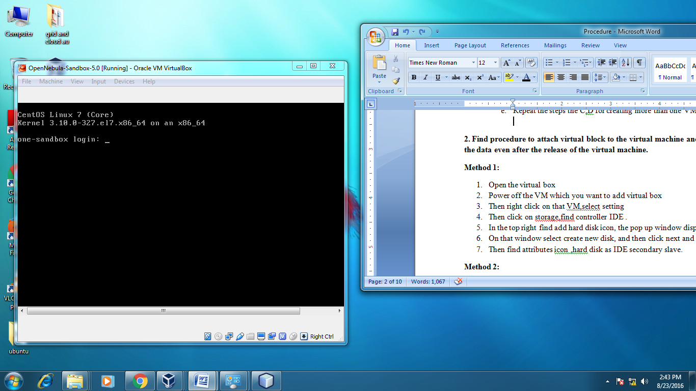

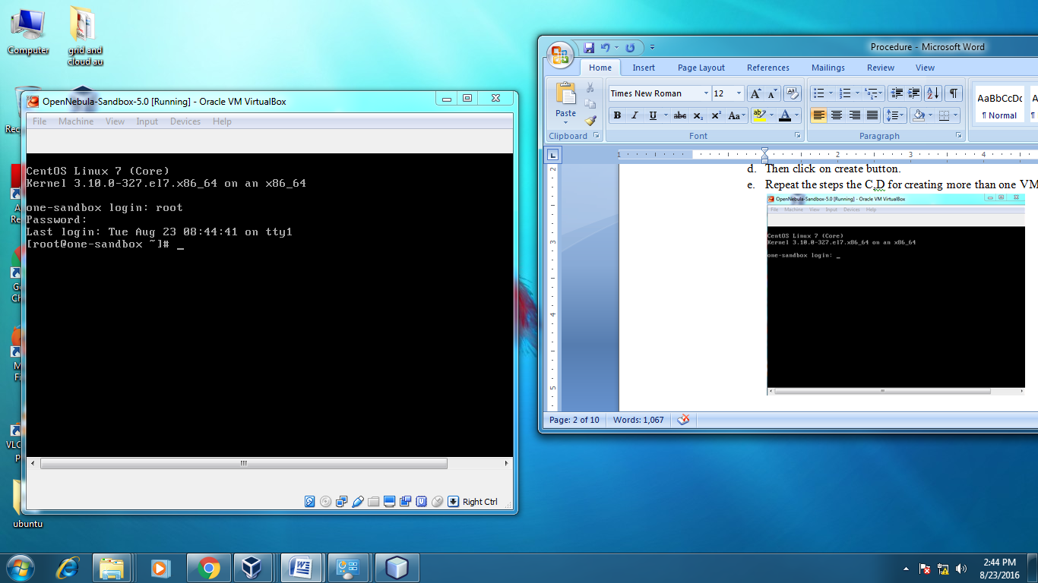

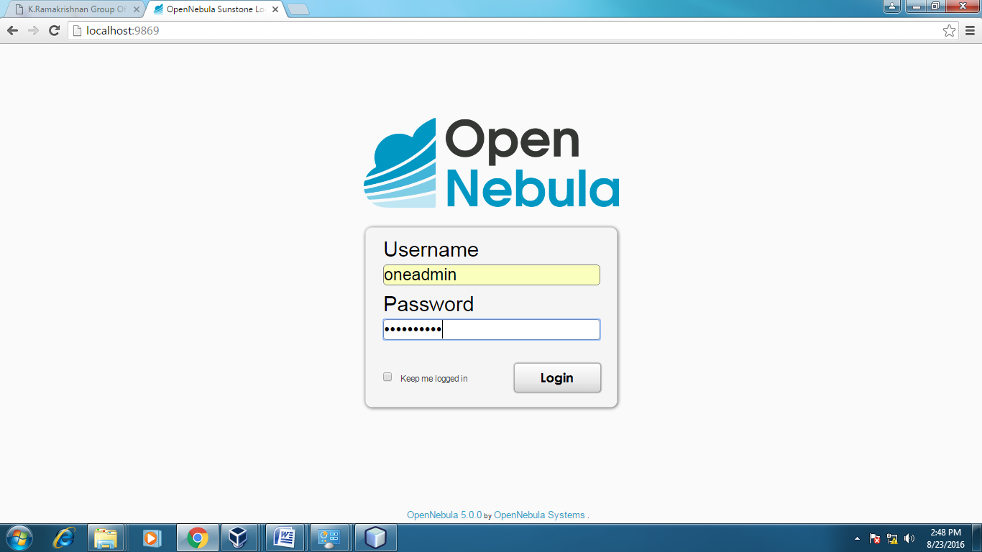
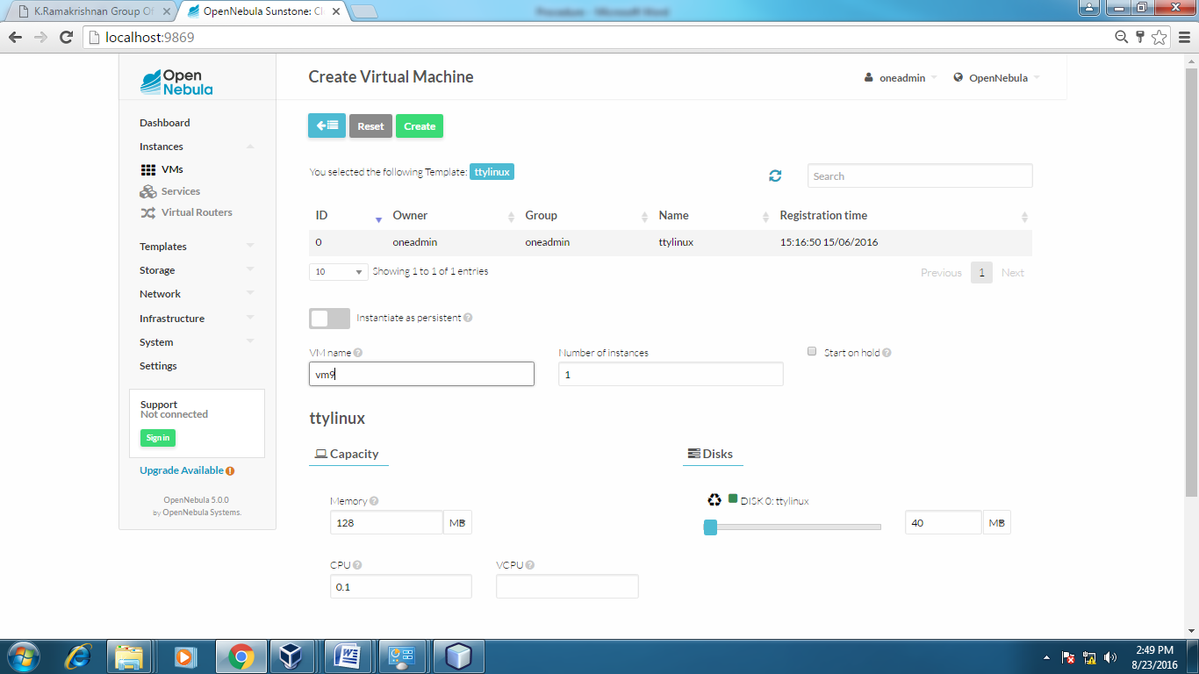
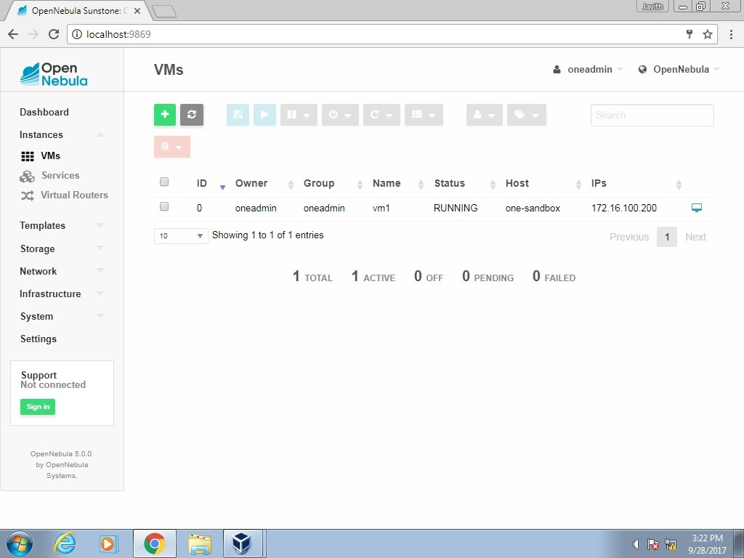

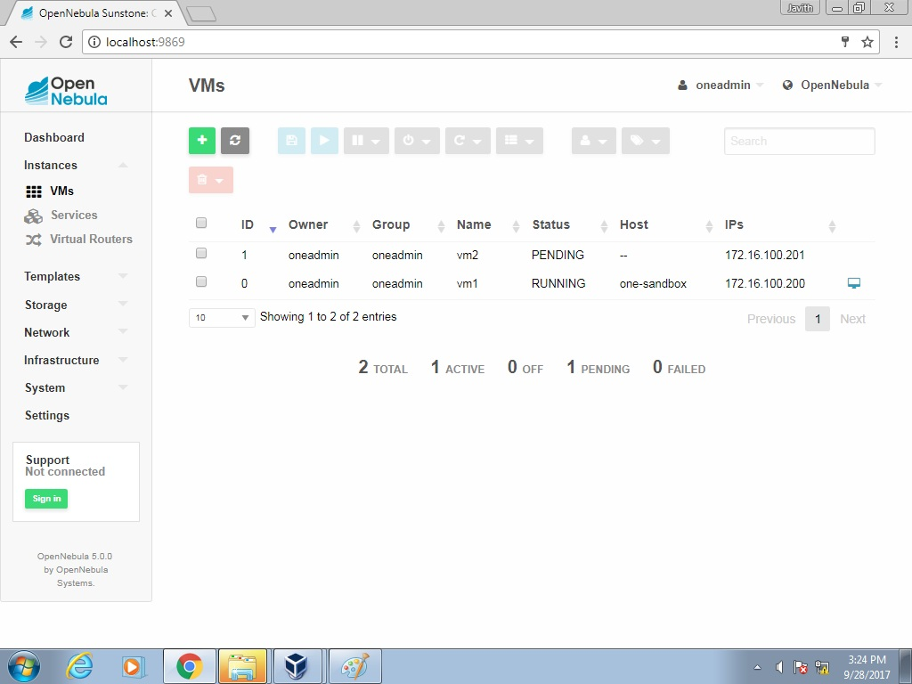

RESULT:

Thus the Virtual Machines of different Configuration are created successfully and checked how many virtual machines can be utilized at a particular time.

Ex No : 2 ATTACH A VIRTUAL BLOCK TO VIRTUAL MACHINE

AIM:

To attach a Virtual Block to Virtual Machine and to check whether it holds the data even after the release of virtual machine.

REQUIREMENTS:
- ORACLE VIRTUAL BOX
- OPEN NEBULA SANDBOX
PROCEDURE:

METHOD 1:
- Open the virtual box
- Power off the VM which you want to add virtual box
- Then right click on that VM,select setting
- Then click on storage,find controller IDE .
- In the top right find add hard disk icon, the pop up window display
- On that window select create new disk, and then click next and next then finish.
- Then find attributes icon ,hard disk as IDE secondary slave.

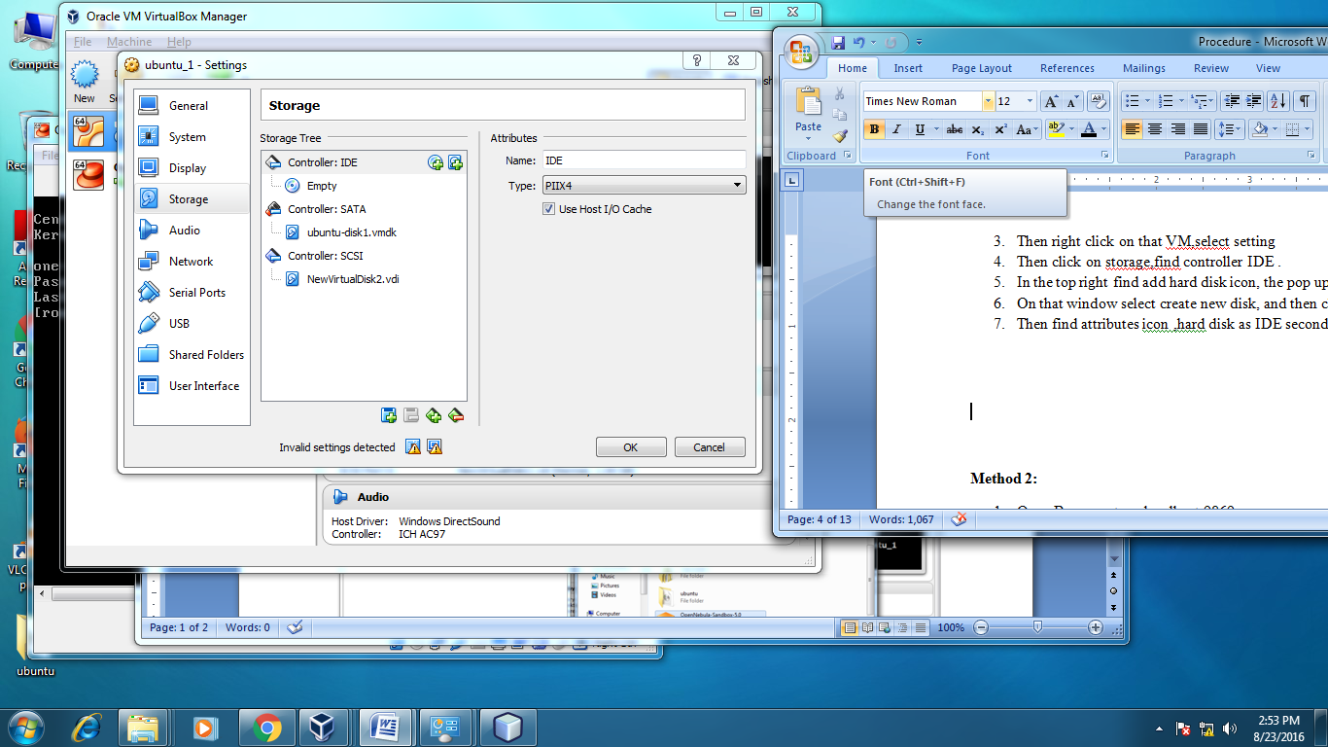

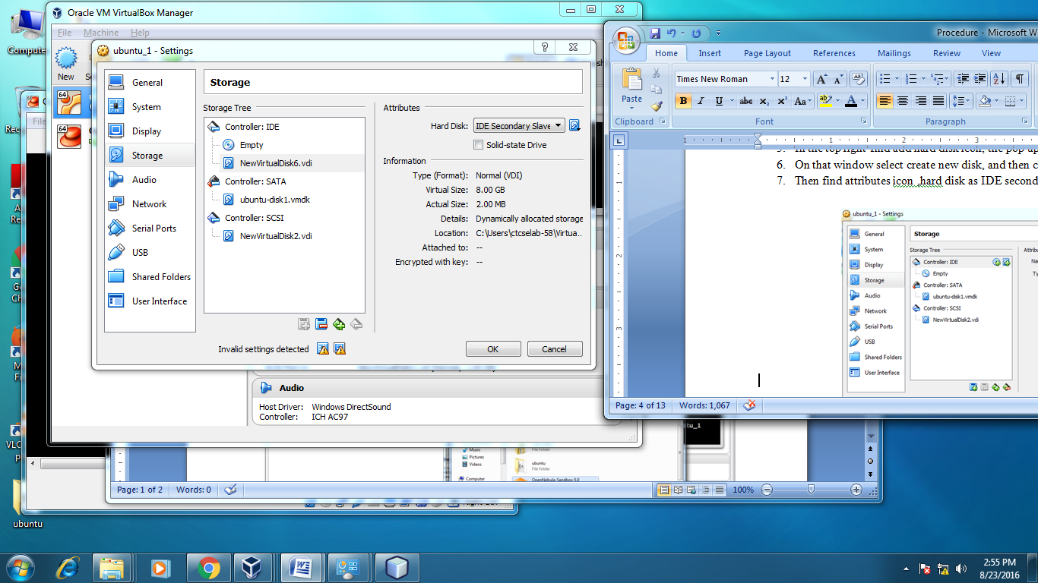

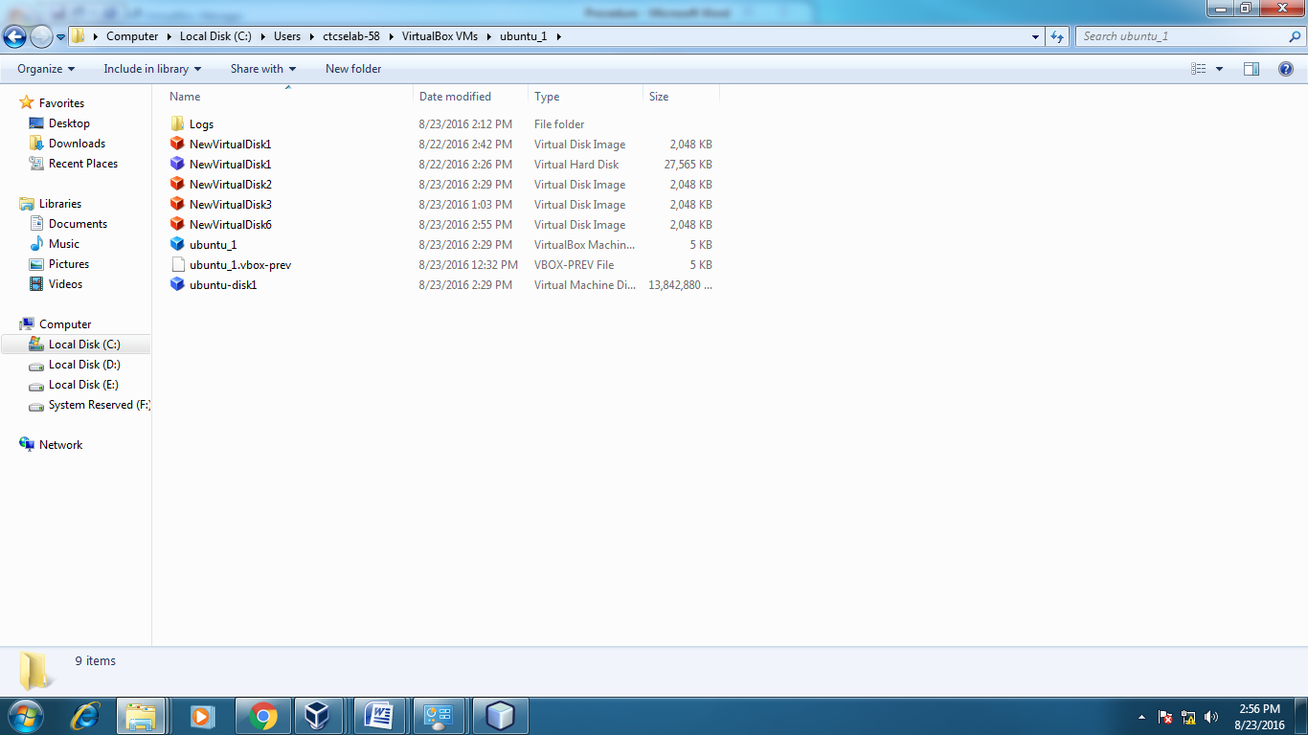
METHOD 2:
- Open Browser, type localhost:9869
- Login using username: oneadmin, password: opennebula
- Click on instances, select VMs then follow the steps to add virtual block
  - Select any one VM from the list and power off the VM
  - Then click on that VM ,find the storage tab then click on that
  - Then find the attach disk button
  - Click on that button ,the new pop window display
  - On that window select either image or volatile disk
  - Click on attach button.

OUTPUT:
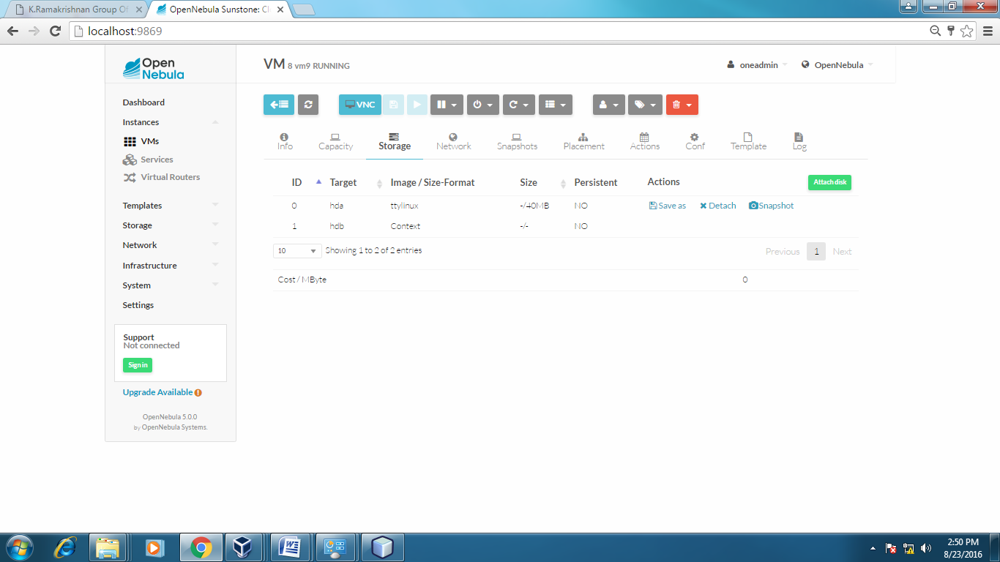
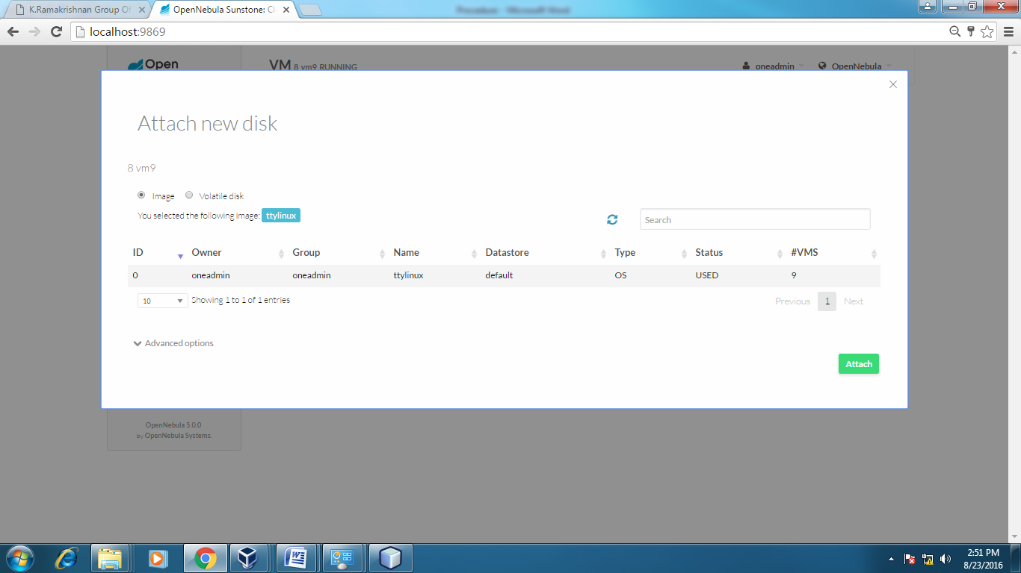

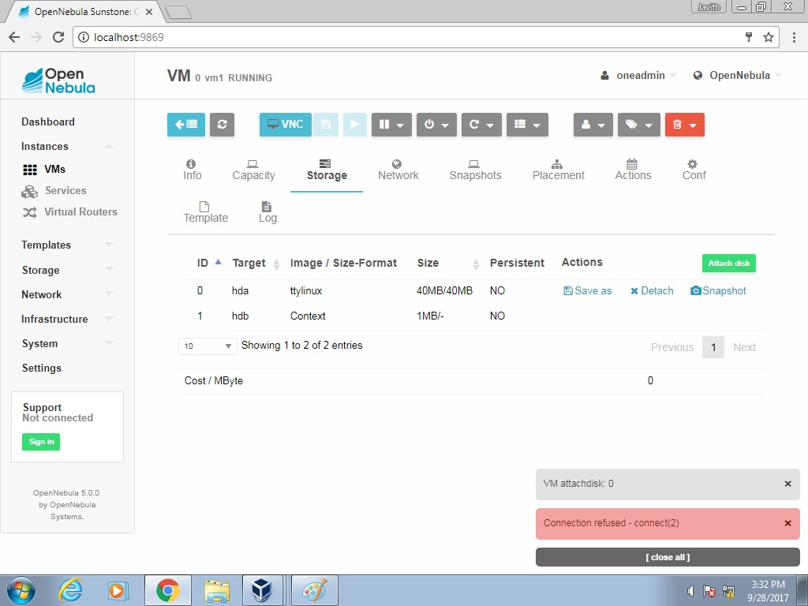

RESULT:
Thus a Virtual Block is attached to a Virtual Machine and checked whether it holds the data even after the release of virtual machine.

EX NO: 3 INSTALL A C COMPILER IN THE VIRTUAL MACHINE AND
EXECUTE A SAMPLE PROGRAM

AIM:

To install a C Compiler in the Virtual Machine and execute a sample program

REQUIREMENTS:
- ORACLE VIRTUAL BOX
- OPEN NEBULA SANDBOX
- UBUNTU Gt6.Ova

PROCEDURE:
STEP 1:
ubuntu_gt6 installation:
- Open Virtual box
- File import Appliance
- Browse ubuntu_gt6.ova file
- Then go to setting, select Usb and choose USB 1.1
- Then Start the ubuntu_gt6
- Login using username: dinesh, password:99425.

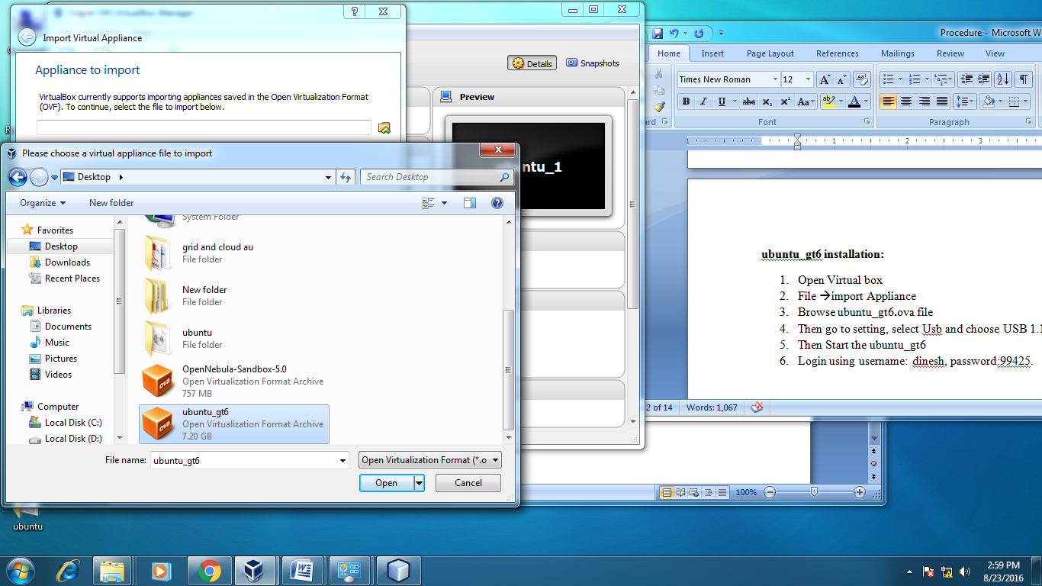
STEP 2:
Open the terminal
STEP 3:
//to install gcc
Sudo add-apt repository ppa:ubuntu-toolchain-r/test
sudo apt-get update
sudo apt-get install gcc-6 gcc-6-base
STEP 4:
To type a sample c program and save it
gedit hello.c
STEP 5:
To compile and run a sample c program
gcc hello.c
./a.out

OUTPUT:
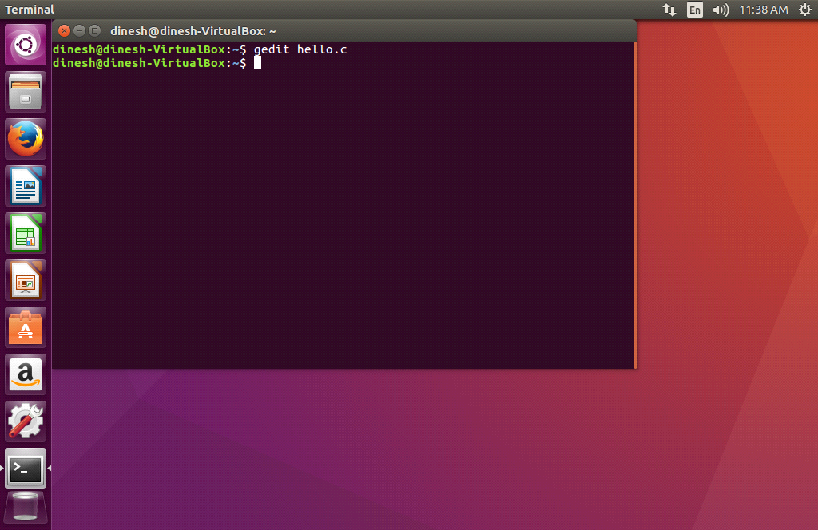

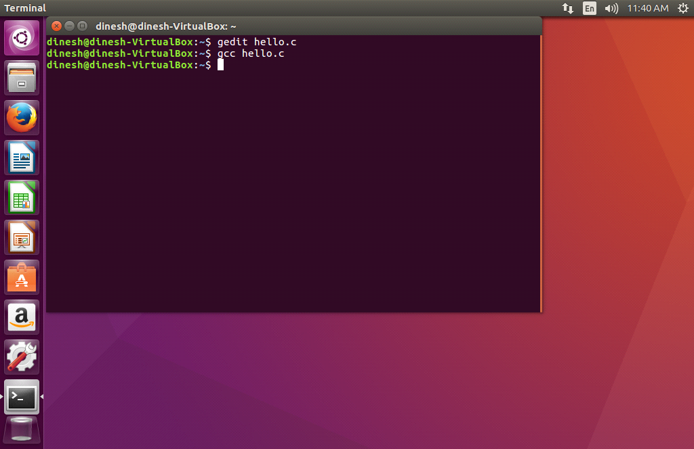

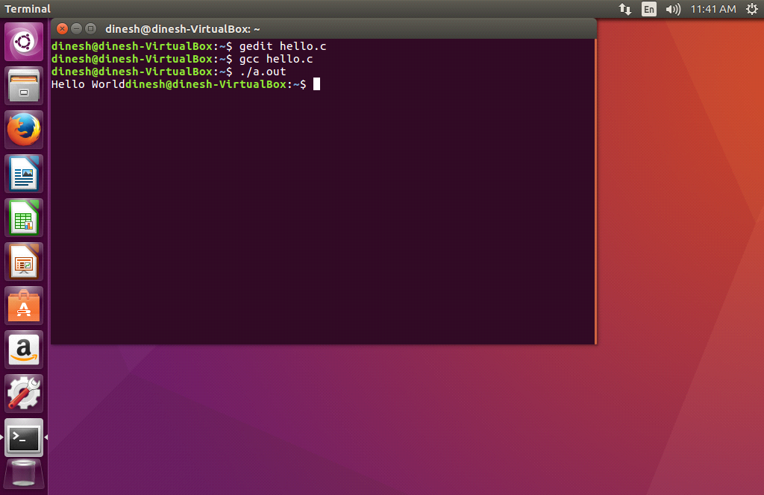

RESULT:

Thus the C Compiler in the Virtual Machine is installed and a sample program is executed successfully.

EX NO: 4 SHOW THE VIRTUAL MACHINE MIGRATION BASED ON CERTAIN
CONDITION FROM ONE NODE TO OTHER

AIM:
To show the virtual machine migration based on the certain condition from one node to the other.
REQUIREMENTS:
- ORACLE VIRTUAL BOX
- OPEN NEBULA SANDBOX
- UBUNTU Gt6.Ova
PROCEDURE:
STEP:1
Open Browser, type localhost:9869
STEP:2
Login using username: oneadmin, password: opennebula
STEP:3
Then follow the steps to migrate VMs
  - Click on infrastructure
  - Select clusters and enter the cluster name
  - Then select host tab, and select all host
  - Then select Vnets tab, and select all vnet
  - Then select datastores tab, and select all datastores
  - And then choose host under infrastructure tab
  - Click on + symbol to add new host, name the host then click on create.
STEP:4
On instances, select VMs to migrate then follow the stpes
  - Click on 8th icon ,the drop down list display
  - Select migrate on that ,the popup window display
  - On that select the target host to migrate then click on migrate.

OUTPUT:
Before migration
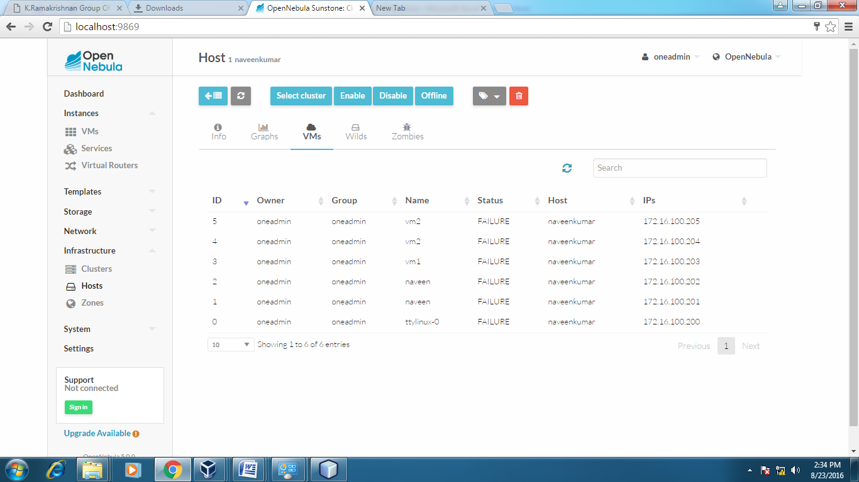
Host:one-sandbox
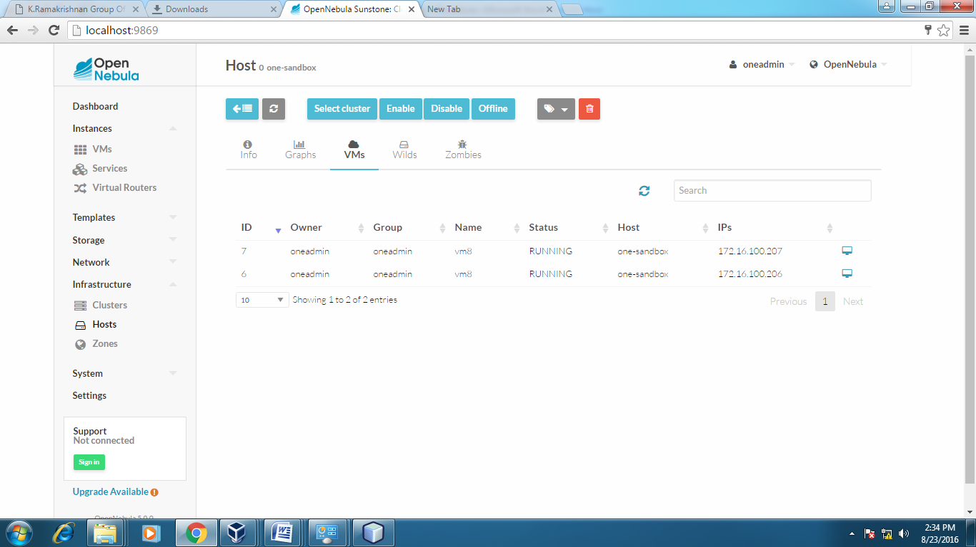
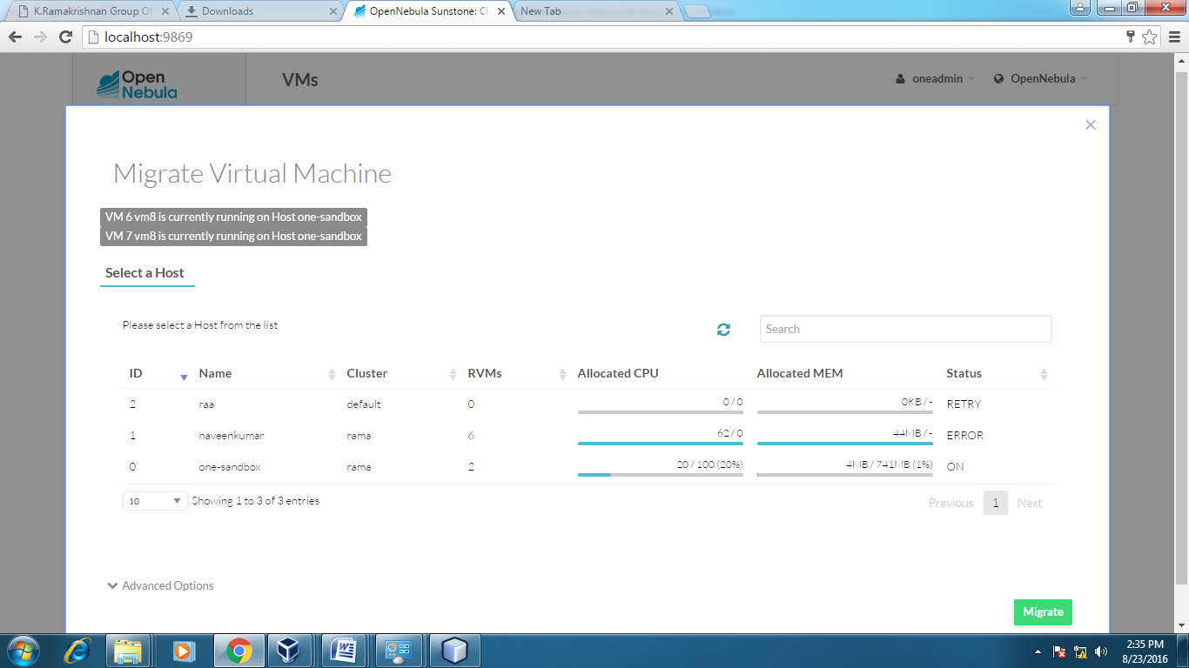

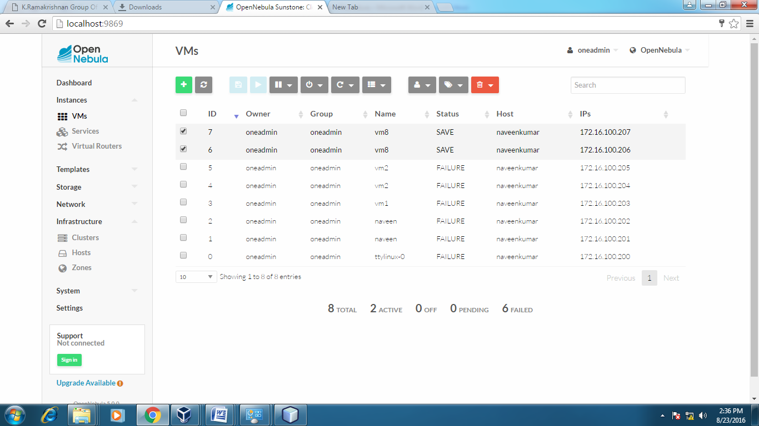

After Migration:
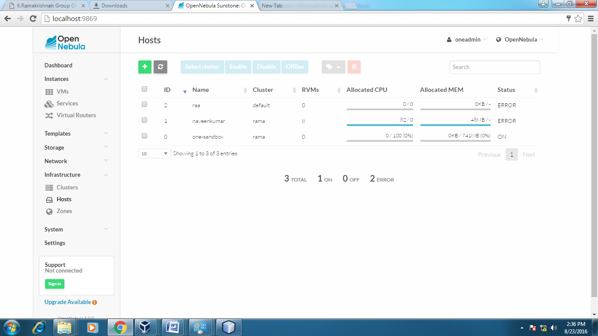

Host:one-sandbox
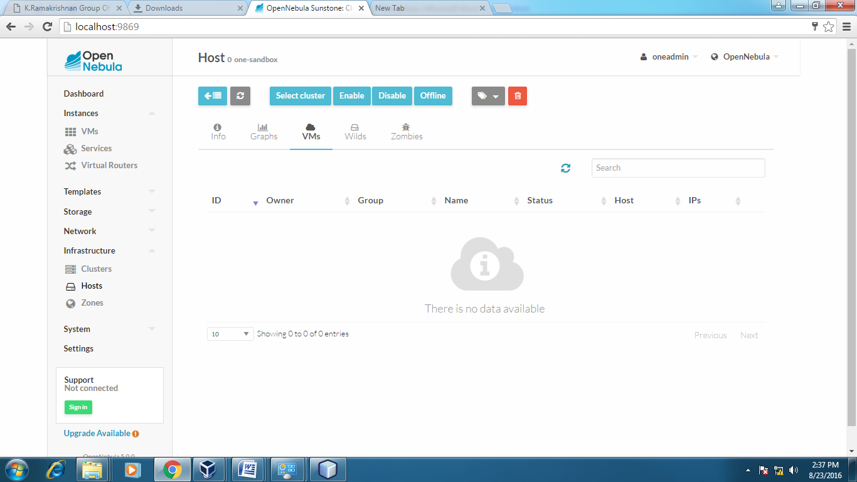
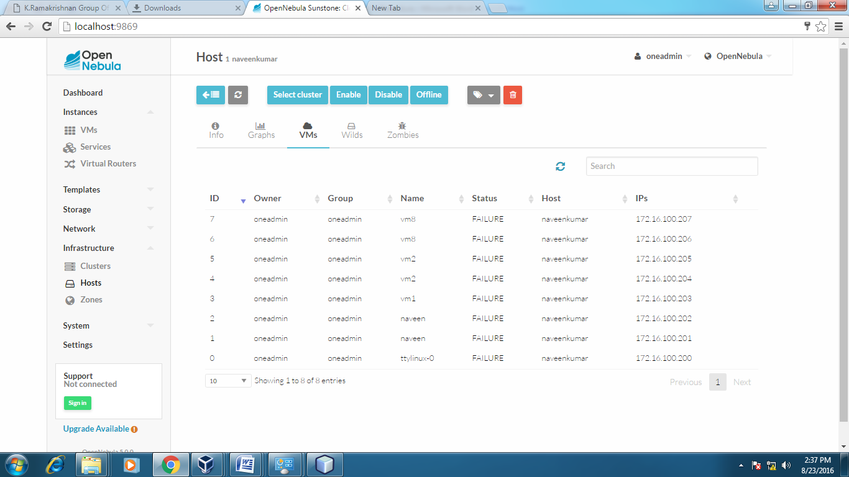

RESULT:
Thus the virtual machine migration based on the certain condition from one node to the other has been successfully executed.

EX NO: 5 STORAGE CONTROLLER

AIM:

To install Storage Controller and to interact with it.

REQUIREMENTS:
- ORACLE VIRTUAL BOX
- OPEN NEBULA SANDBOX
- UBUNTU Gt6.Ova

PROCEDURE:

Nova compute instances support the attachment and detachment of Cinder storage volumes. This procedure details the steps involved in creating a logical volume in the cinder-volumes volume group using the cinder command line interface.

METHOD: 1(using ubuntu GT6)
- After login plug-in the USB drive
- Right Click on the USB icon at bottom right corner(4th Icon)
- Select your device name like jetflash, sandisk etc
- Explorer window open.
- Then do read, write operations on the USB.
METHOD: 2

STEP: 1

Log in to the dashboard.
STEP: 2
Select the appropriate project from the drop down menu at the top left.
STEP: 3
On the Project tab, open the Compute tab and click Access & Security category.
STEP: 4
On the Access & Security tab, click API Access category and click Download Openstack RC File V2.0
STEP: 5
source ./admin-openrc.sh

STEP: 6
Create Cinder Volume. Use the cinder create command to create a new volume.
$ cinder create --display_name NAME SIZE.

OUTPUT:

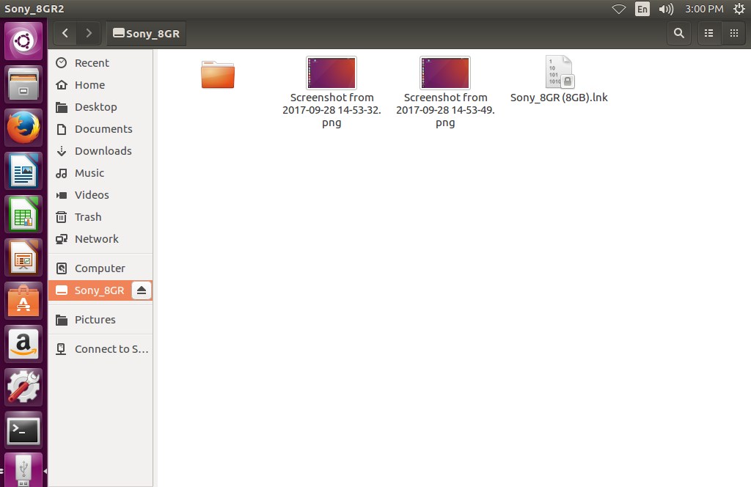

RESULT:
Thus the Storage Controller is installed and interaction with it, is done successfully.

EX NO: 6 HADOOP INSTALLATION

AIM:

To install Hadoop Software and to set up the one node Hadoop cluster.

PROCEDURE:

STEP 1:INSTALLING JAVA
Step 1.1:Download jdk tar.gz file for Ubuntu 64 bit OS
$tar zxvf jdk-8u60-linux-x64.tar.gz
$cd jdk1.8.0-60/
$pwd
/home/Downloads/jdkcopy the path of jdk
Step 1.2:To set the environment variables for java
$ sudo nano /etc/profile
Pwd:
Add following three lines at the mid file
JAVA_HOME=/home/Downloads/jdk 1.8.0_60(paste path here)
PATH=$PATH:$JAVA_HOME/bin
Export PATH JAVA_HOME
Save the file by pressing ctrl+x,press y&enter
Step 1.3:source /etc/profile
Step 1.4:java -version
You will get “java hotspot(TM)64 bit server as last line
If you are not getting this,Update java alternatives
#update_alternatives__install “us a/bin/java”java
#java_version
STEP 2:INSTALLING HADOOP
Step 2.1:Download latest version of hadoop tar.gz(hadoop-2.7.0)
#cd..
#tar zxvf hadoop-2.7.0 tar.gz
#cd hadoop-2.7.0/ (to go to file)
#pwd
/home/Downloads/hadoop-2.7.0-copy the path of hadoop
Step 2.2:To set the environment variables for hadoop
#sudo nano /etc/profile
Pwd:
Add the following three lines
HADOOP_PREFIX=/home/Downloads/hadoop 2.7.0
PATH=$PATH:$HADOOP_PREFIX/bin
Export PATH JAVA_HOME HADOOP_PREFIX
Save the file by pressing ctrl+x, press y&enter
Step 2.3:#source /etc/profile
#cd $HADOOP_PREFIX
#bin/hadoop version
Hadoop 2.7.0
Step 2.4:Update java,hadoop path to hadoop environment file
#cat /etc/profile(copy JAVA_HOME lines)HADOOP_PREFIX
#cd $HADOOP_PREFIX /etc/hadoop
#nano hadoop-env.sh
After lastline,paste the path and add export at the file
export JAVA_HOME=/home/Downloads/jdk
export HADOOP_PREFIX=/home/downloads/hadoop
STEP 3:INSTALLING PACKAGE OPEN SSH(configuring SSH)
Step 3.1:#sudo apt-get install open ssh-server
Press y for all
Unable to fetch
#sudo nano /etc/resolv.conf
Add nameserver 8.8.8.8
Save file by pressing ctrl+x, press y and enter
#sudo apt-get install open ssh-server
Press y for all
Step 3.2:To establish password less communication between system
#ssh localhost
#ssh-keygen
Given enter for all
#ssh-copy-id -i localhost
Press y
Yes
Pwd:
You will get “No.of keys added:/”
STEP 4:TO CONFIGURE FOUR XML FILES
(to configure what is the file system in which its configured)
Step 4.1:Modify core-site.xml
$nano core-site.xml
In that file, paste
<configuration>
<property>
<name>fs.defaultFS</name>
<value>hdfs://localhost:9000</value>
</property>
</configuration>
Save file by processing ctrl+x,press y and enter
Step 4.2:To configure number of replication, modify hdfs-site.xml
$nano hdfs-site.xml
In hdfs-site.xml file, paste
<configuration>
<property>

<name>dfs.replication</name>

<value>1</value>

</property>
</configuration>

ctrl+x, press y and enter
Step 4.3:Modify mapred-site.xml
$cp mapred-site.xml.template mapred-site.xml
$nano mapred-site.xml
In that file, paste
<configuration>

<property>

<name>mapreduce.framework.name</name>

<value>yarn</value>

</property>

</configuration>

Step 4.4:Modify yarn-site.xml
In that file, paste
<configuration>

<property><name>yarn.nodemanager.aux-services</name>
<value>mapreduce_shuffle</value></property>

</configuration>

STEP 5:FORMAT HDFS FILE SYSTEM (via name node for first time)
#cd $HADOOP_PREFIX
#bin/hadoop namenode -format
Step 5.1:Start name node and data node(port 50070)
#sbin/start-dfs.sh
Press y, yes
If error occurs ssh-add
To know running name node and data node Daemon type
#jps[In browser, type local host:50070,give enter , name node information is displayed]
Step 5.2:Start resource manager and node manager Daemon(port 8088)
#sbin/start-yarn.sh
#jps
Step 5.3:To stop the running process
#sbin/stop-dfs.sh
#sbin/stop-yarn.sh

OUTPUT:
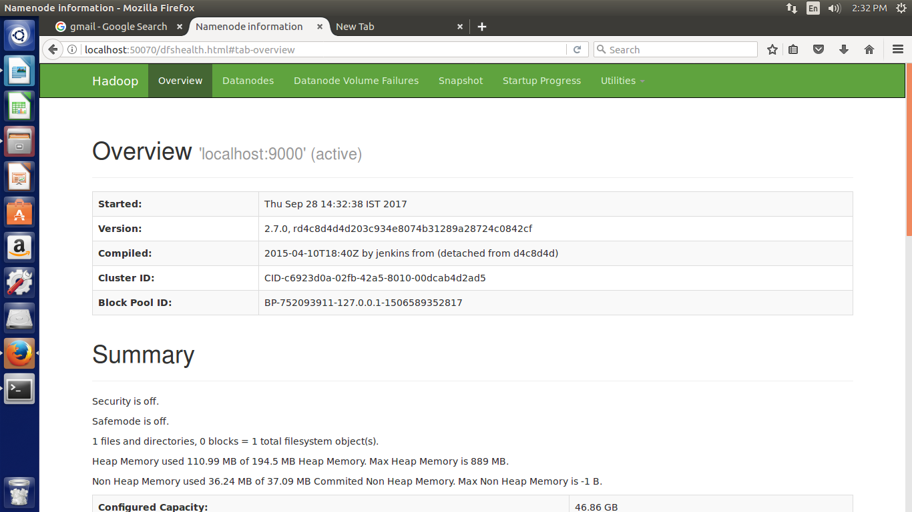
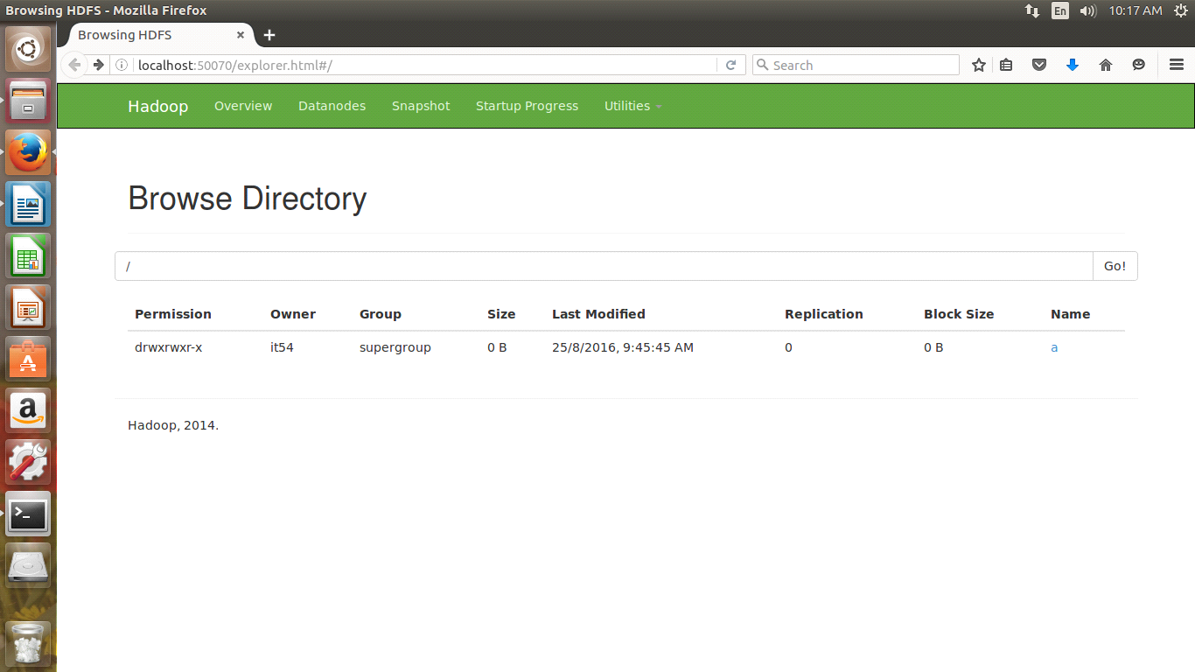
RESULT:
Thus the Hadoop Software is installed and the one node Hadoop cluster is set up successfully

EX NO: 7 MOUNT THE ONE NODE HADOOP CLUSTER USING FUSE

AIM:
To Mount the one node Hadoop cluster using FUSE.
.
PROCEDURE:

STEP: 1
wget http://archive.cloudera.com/cdh5/one-click-install/trusty/amd64/cdh5-repository_1.0_all.deb

STEP: 2
sudo dpkg -i cdh5-repository_1.0_all.deb

STEP: 3
sudo apt-get update

STEP: 4
sudo apt-get install hadoop-hdfs-fuse

STEP: 5
sudo mkdir -p xyz

STEP: 6
cd hadoop-2.7.0/

STEP: 7
bin/hadoop namenode -format

STEP: 8
sbin/start-all.sh

STEP: 9
hadoop-fuse-dfs dfs://localhost:9000 /home/it08/Downloads/xyz/

STEP: 10
sudo chmod 777 /home/it08/Downloads/xyz/

STEP: 11
hadoop-fuse-dfs dfs://localhost:9000 /home/it08/Downloads/xyz/

STEP: 12
cd /home/it08/Downloads/xyz/

STEP: 13
mkdir a
ls

OUTPUT:

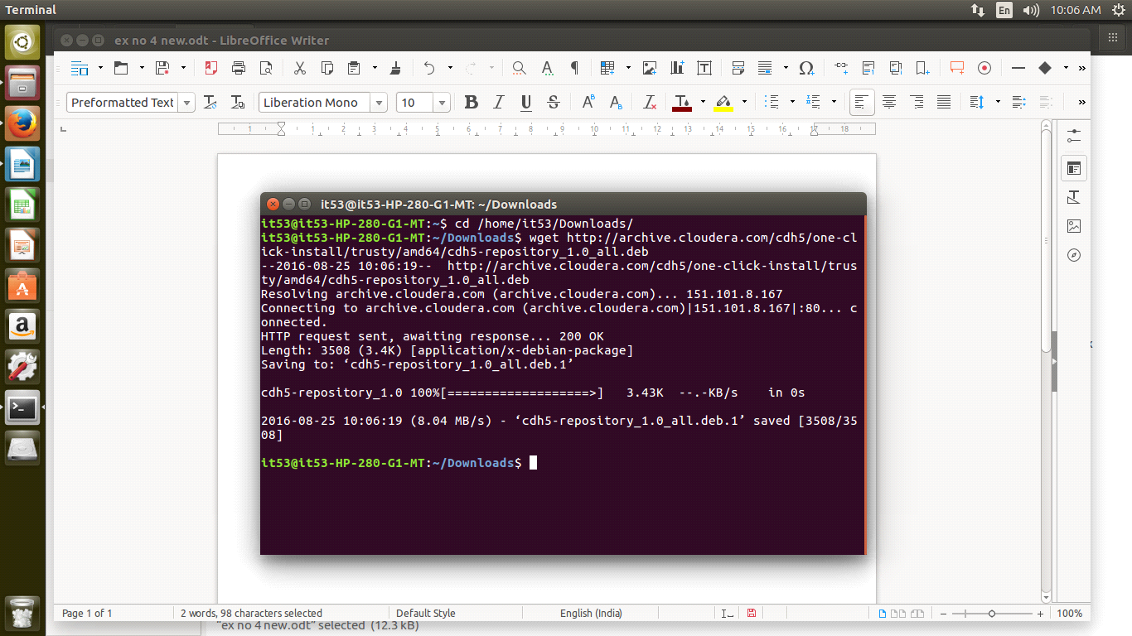

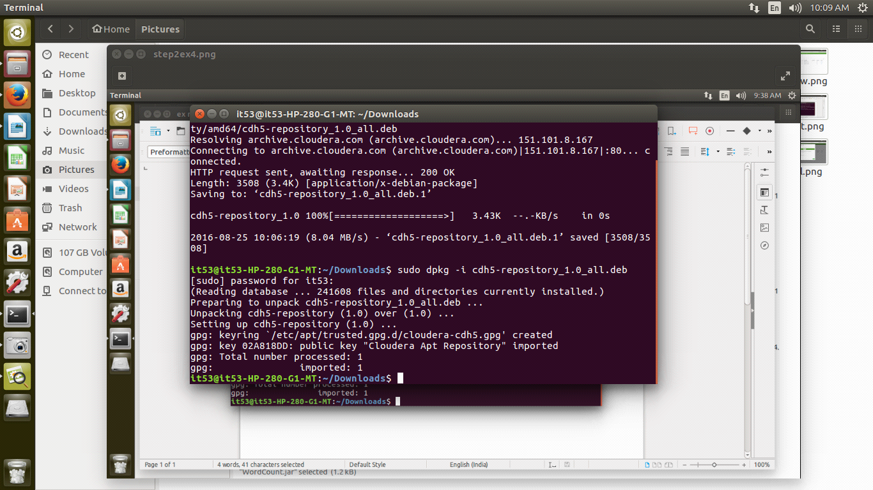

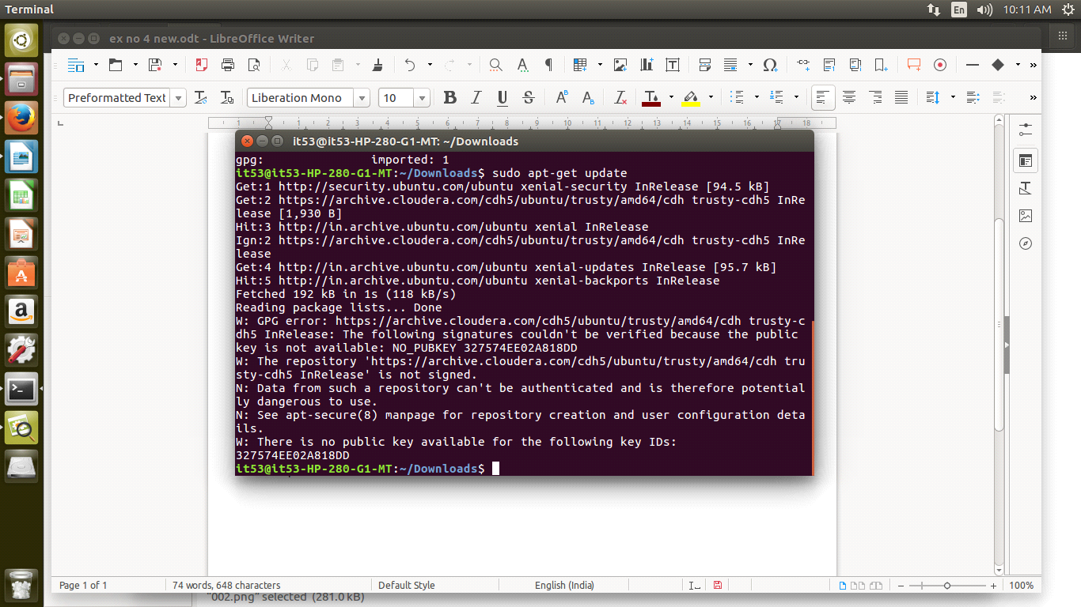

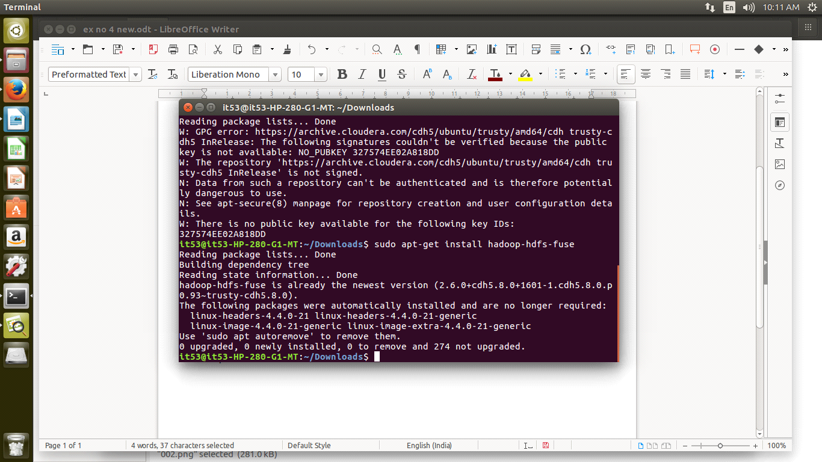

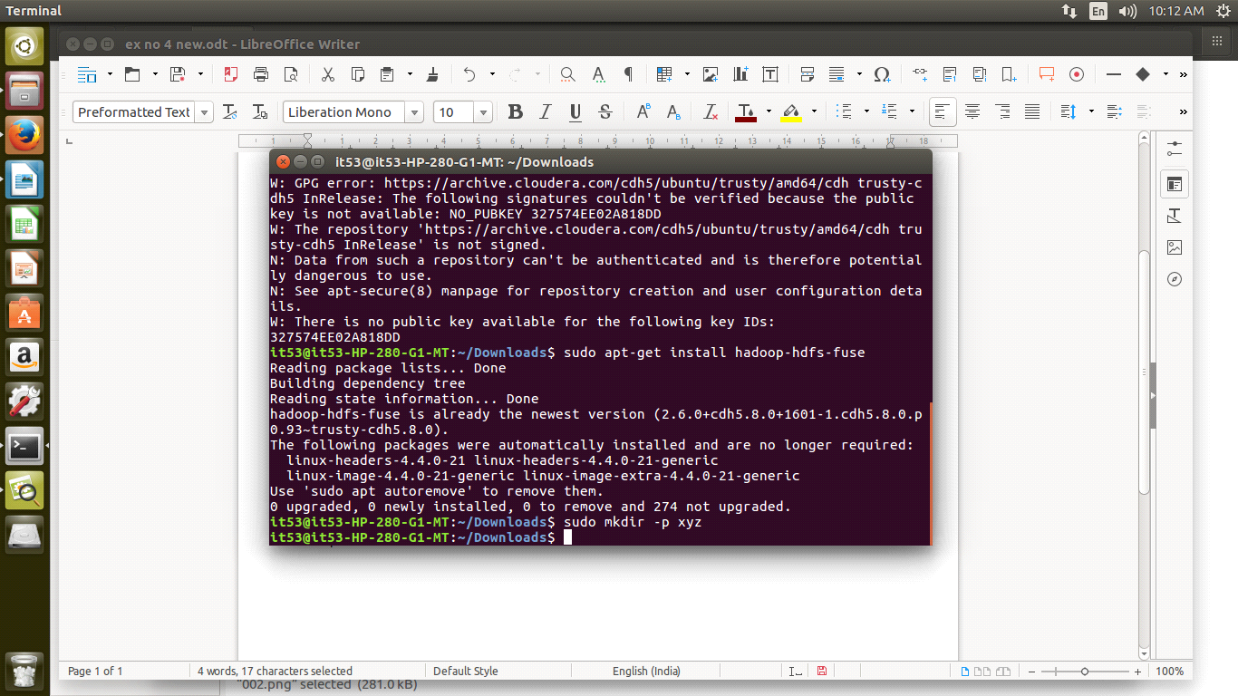

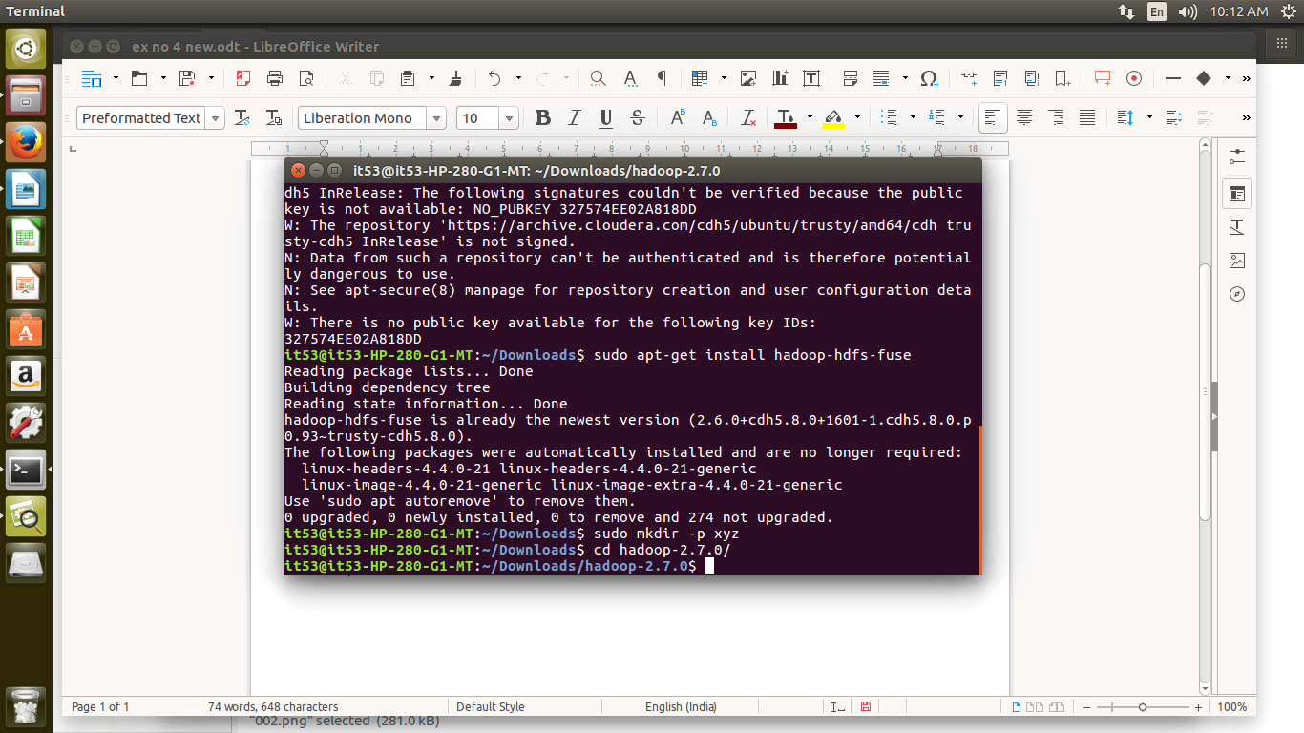

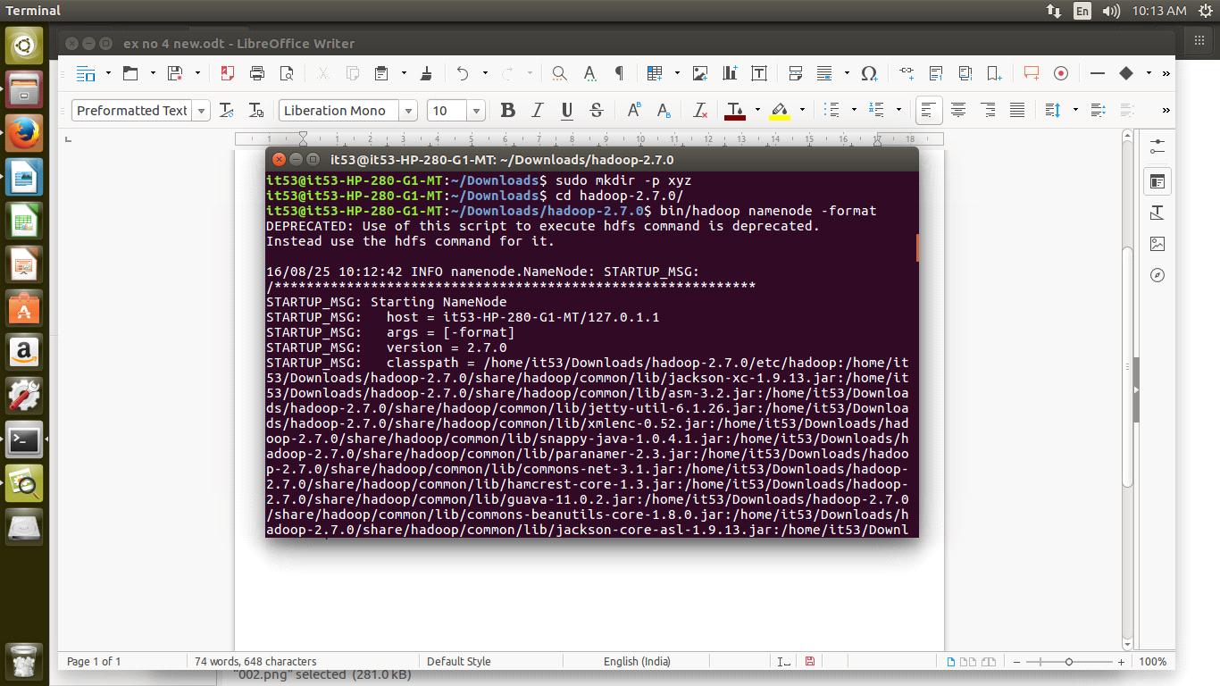

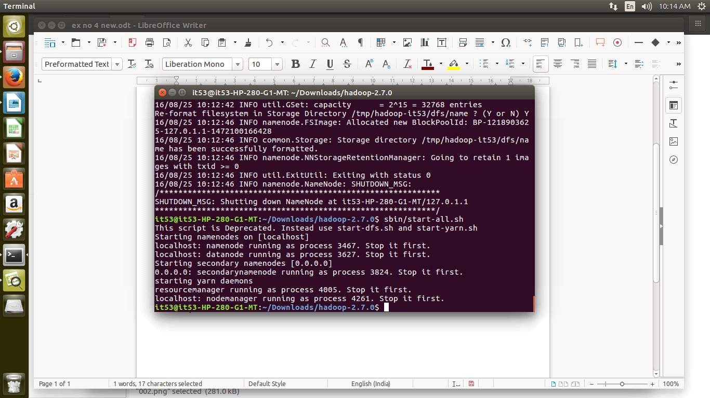

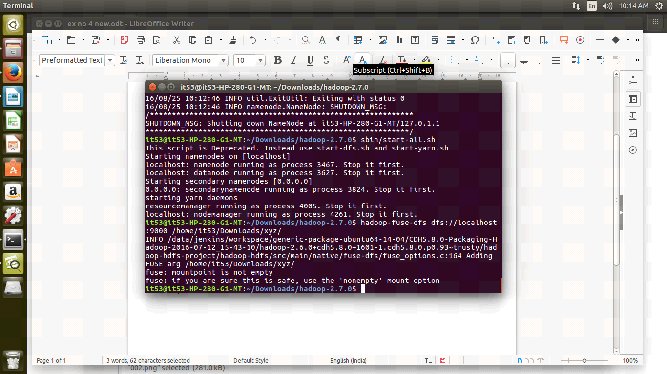

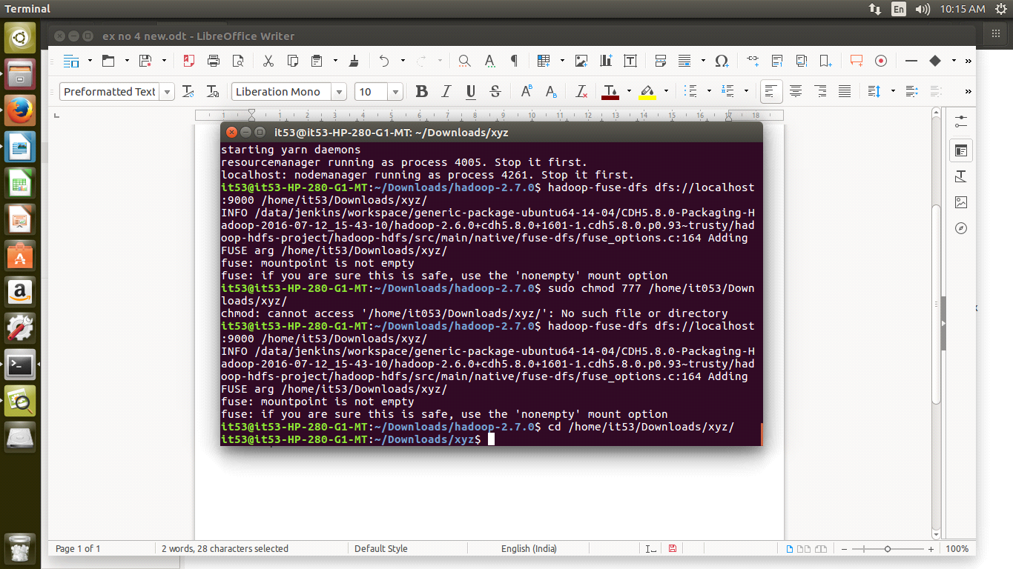

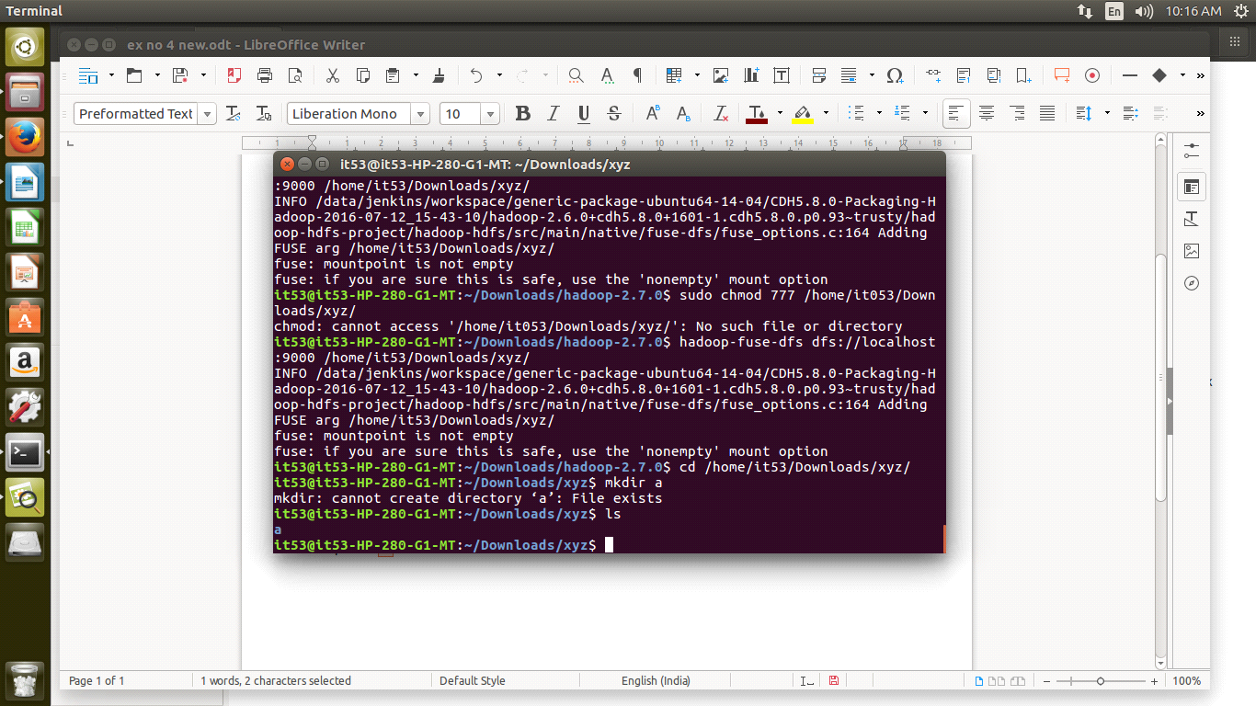

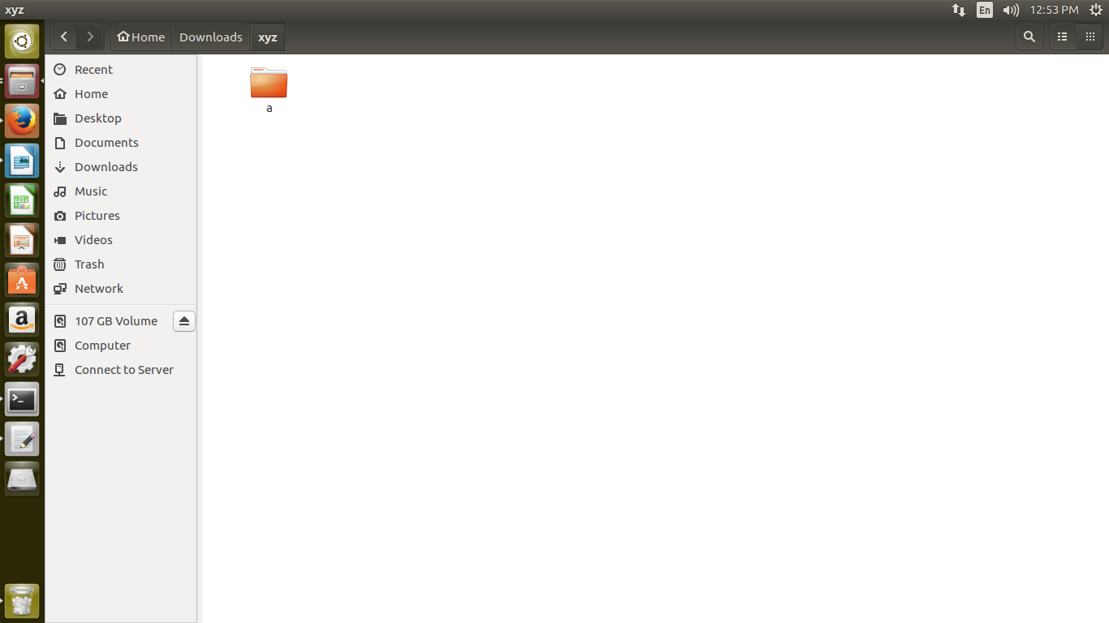

RESULT:
Thus one node Hadoop cluster is mounted using FUSE successfully.

EX NO: 8 A WORD COUNT PROGRAM USING MAP-REDUCE TASKS

AIM:

To write a wordcount program to demonstrate the use of Map and Reduce tasks.

PROCEDURE:

STEP: 1
Download Hadoop-core-1.2.1.jar, which is used to compile and execute the MapReduce program. Visit the following link http://mvnrepository.com/artifact/org.apache.hadoop/hadoop-core/1.2.1 to download the jar. Let us assume the downloaded folder is /home/hadoop/.
STEP: 2
The following commands are used for compiling the WordCount.java program.
javac -classpath hadoop-core-1.2.1.jar -d . WordCount.java
STEP: 3
Create a jar for the program.
jar -cvf sample1.jar sample1/
STEP: 4
cd $HADOOP_PREFIX
bin/hadoop namenode -format
sbin/start-dfs.sh
sbin/start-yarn.sh
jps
STEP: 5
The following command is used to create an input directory in HDFS.
bin/hdfs dfs -mkdir /input
STEP: 6
The following command is used to copy the input file named sal.txt in the input directory of HDFS.
bin/hdfs dfs -put /home/it08/Downloads/sal.txt /input
STEP: 7
The following command is used to run the application by taking the input files from the input directory.
bin/hadoop jar /home/it08/Downloads/sample1.jar sample1.WordCount /input /output

PROGRAM:

WordCount.java

package sample;
import java.io.IOException;
import java.util.StringTokenizer;
import org.apache.hadoop.conf.Configuration;
import org.apache.hadoop.fs.Path;
import org.apache.hadoop.io.IntWritable;
import org.apache.hadoop.io.Text;
import org.apache.hadoop.mapreduce.Job;
import org.apache.hadoop.mapreduce.Mapper;
import org.apache.hadoop.mapreduce.Reducer;
import org.apache.hadoop.mapreduce.lib.input.FileInputFormat;
import org.apache.hadoop.mapreduce.lib.output.FileOutputFormat;
public class WordCount {
public static class TokenizerMapper
extends Mapper<Object, Text, Text, IntWritable>{

private final static IntWritable one = new IntWritable(1);
private Text word = new Text();
public void map(Object key, Text value, Context context
) throws IOException, InterruptedException {
StringTokenizer itr = new StringTokenizer(value.toString());
while (itr.hasMoreTokens()) {
word.set(itr.nextToken());
context.write(word, one);
}
}
}

public static class IntSumReducer
extends Reducer<Text,IntWritable,Text,IntWritable> {
private IntWritable result = new IntWritable();
public void reduce(Text key, Iterable<IntWritable> values,
Context context
) throws IOException, InterruptedException {
int sum = 0;
for (IntWritable val : values) {
sum += val.get();
}
result.set(sum);
context.write(key, result);
}
}
public static void main(String[] args) throws Exception {
Configuration conf = new Configuration();
Job job = Job.getInstance(conf, "word count");
job.setJarByClass(WordCount.class);
job.setMapperClass(TokenizerMapper.class);
job.setCombinerClass(IntSumReducer.class);
job.setReducerClass(IntSumReducer.class);
job.setOutputKeyClass(Text.class);
job.setOutputValueClass(IntWritable.class);
FileInputFormat.addInputPath(job, new Path(args[0]));
FileOutputFormat.setOutputPath(job, new Path(args[1]));
System.exit(job.waitForCompletion(true) ? 0 : 1);
}
}
INPUT FILE: (Sample.txt)
1949 12 12 34 23 45 34 12 23
1987 13 11 32 34 45 56 12 34
1997 12 12 12 12 12 11 34 12
1998 23 34 23 34 45 56 23 34
2000 10 11 12 23 14 13 15 16

OUTPUT:

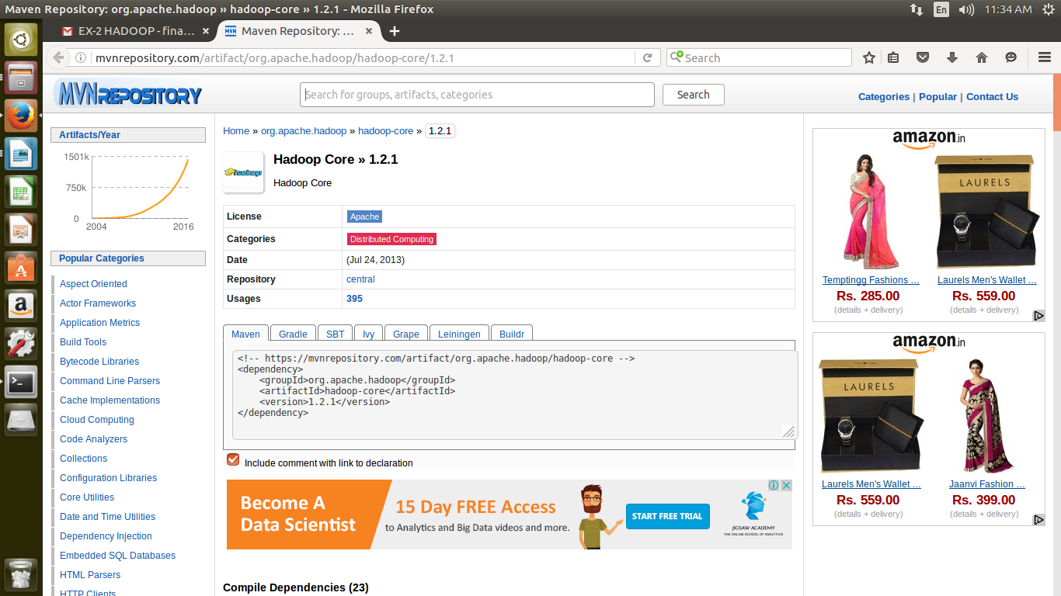

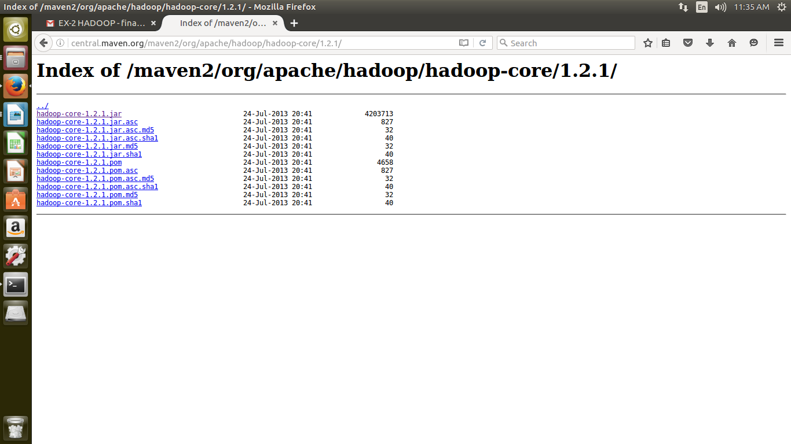

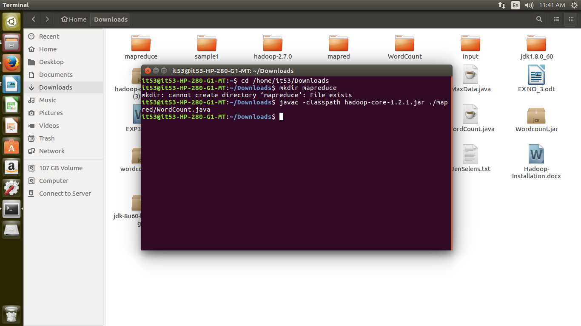

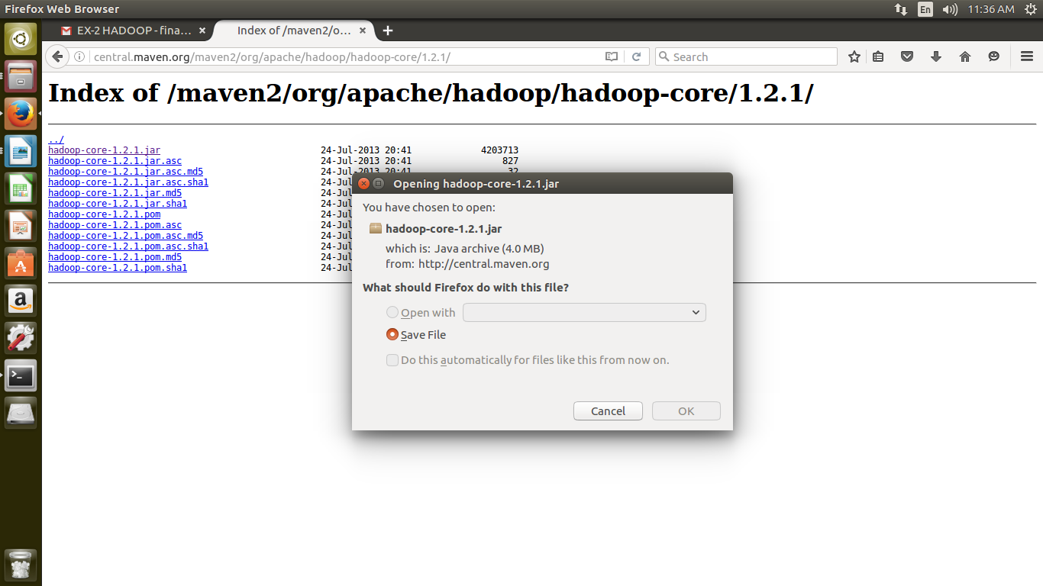

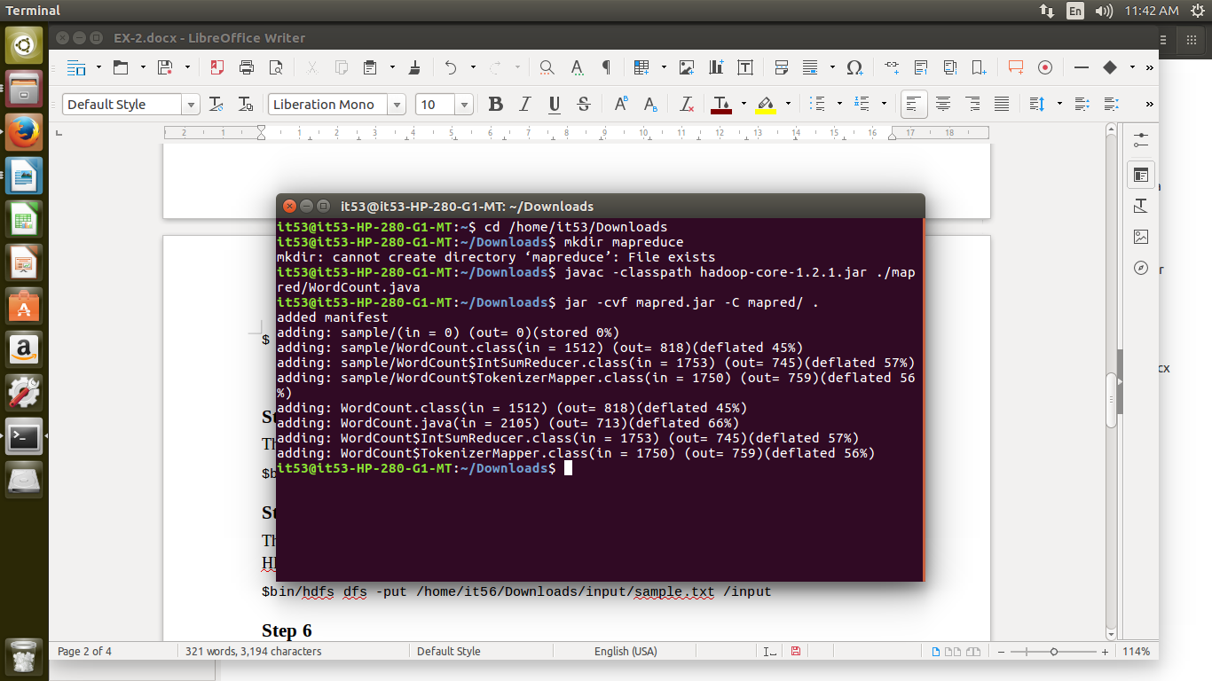

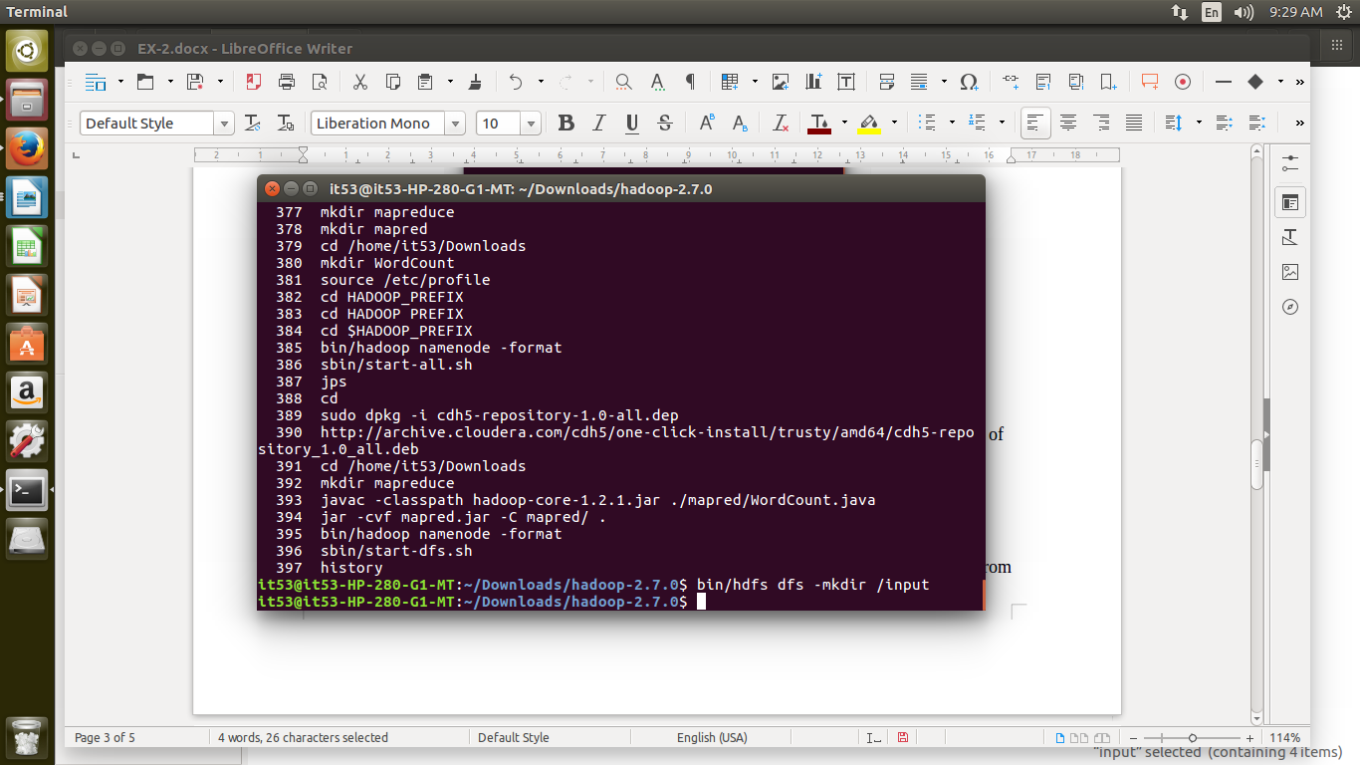

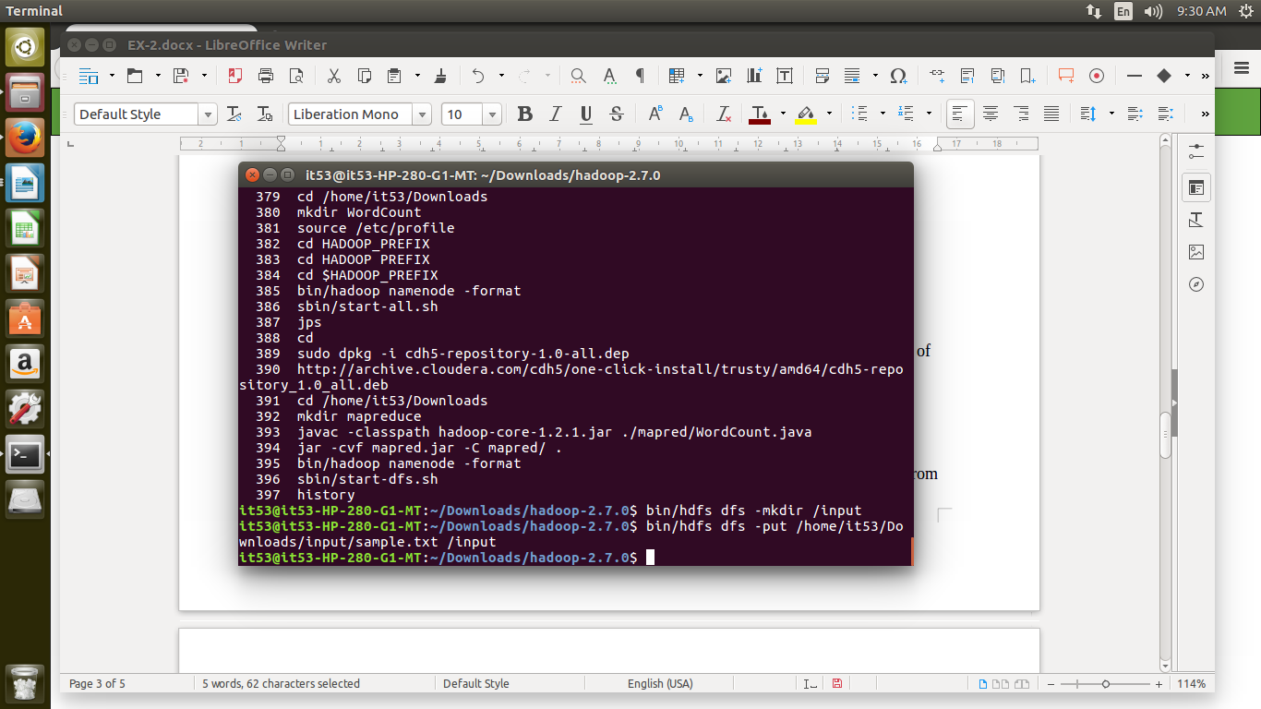

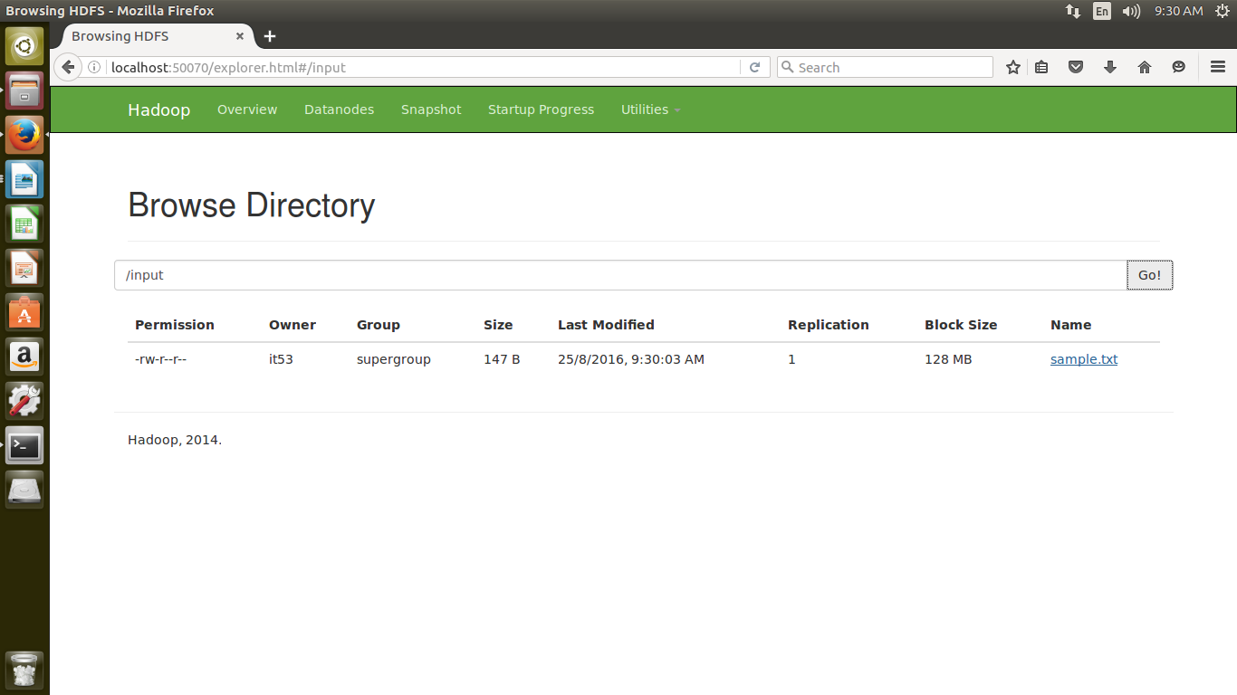

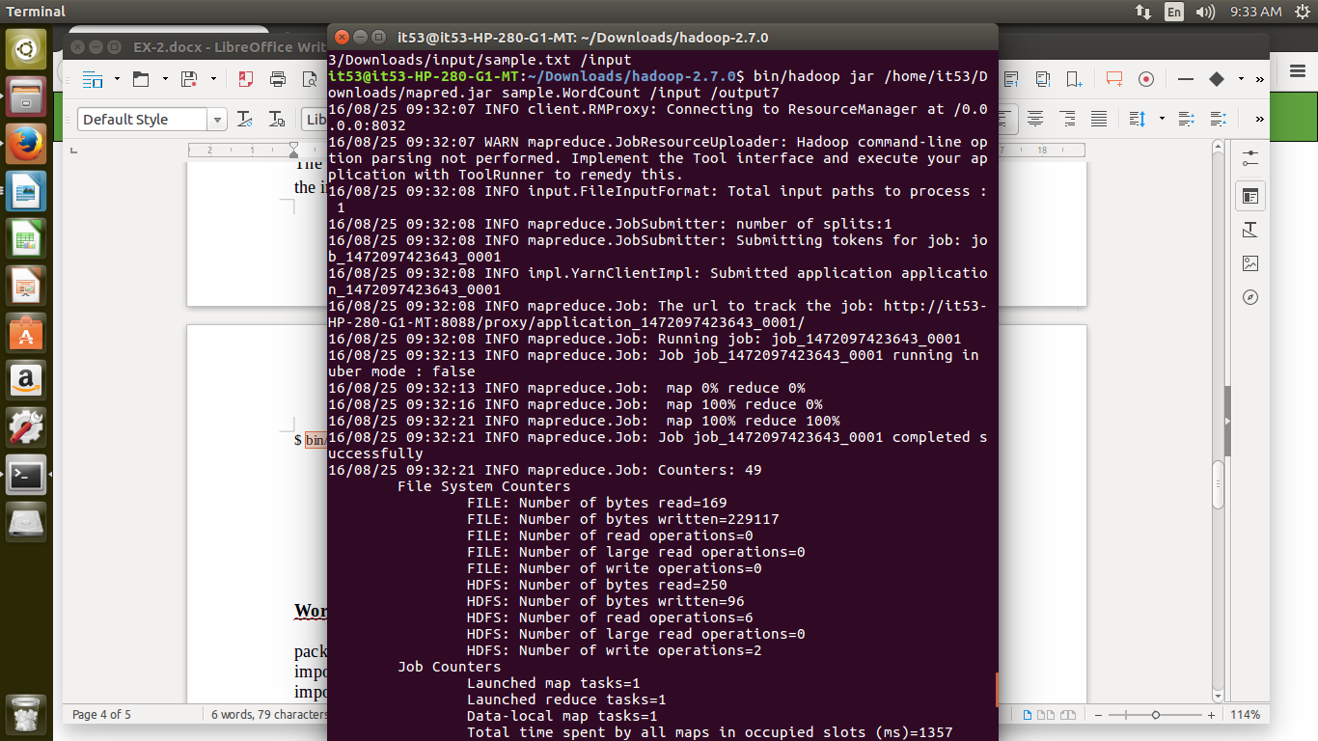

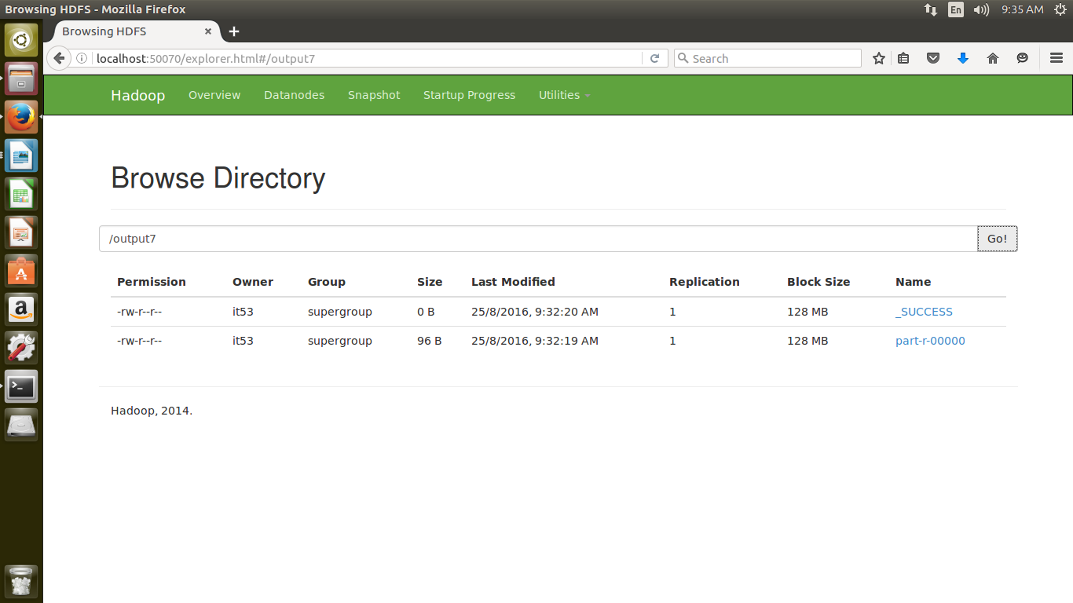

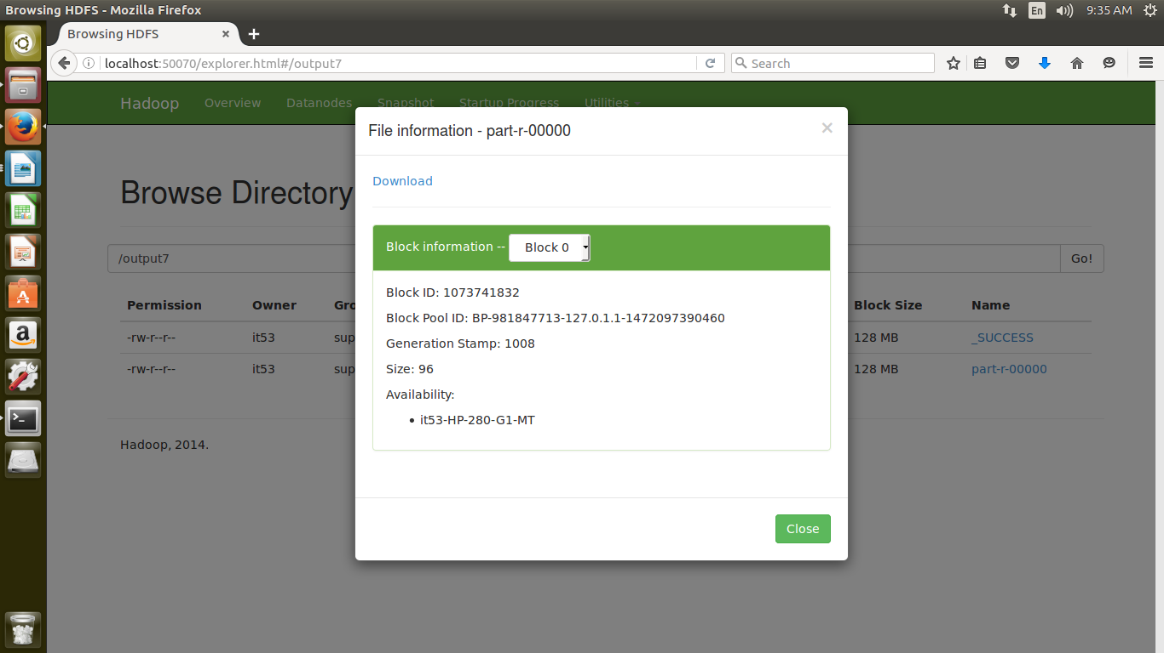

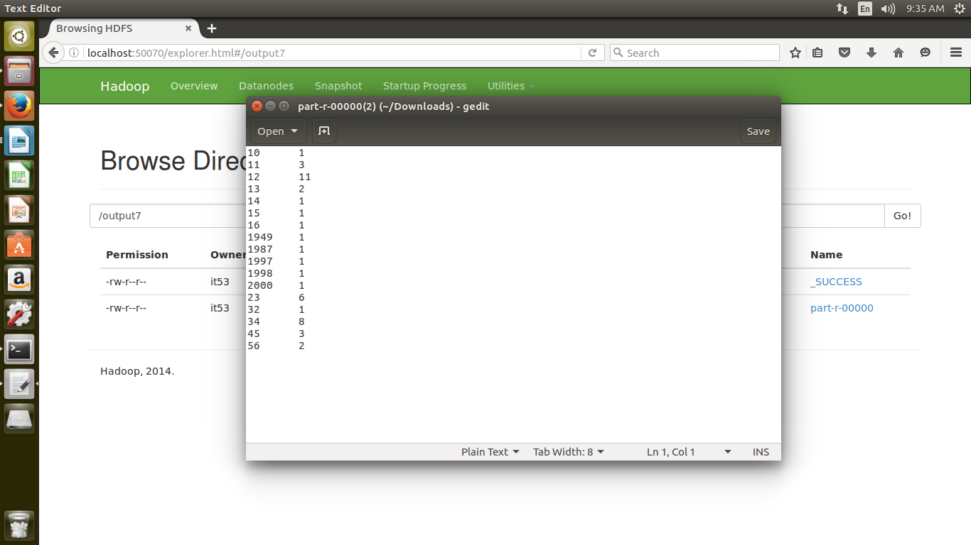

RESULT:
Thus the word count program to demonstrate the use of Map and Reduce tasks is executed successfully.

